1)
(a) Command Used : more /proc/cpuinfo
No. Of Processors : 2 ( namely 0 and 1)
There are 2 cores in each processor

(b) Command Used : more /proc/cpuinfo
Cpu Mhz = 2419.198

(c) Command Used : more /proc/meminfo
MemTotal: 4020204 kB
MemFree: 180640 kB

(d) Command Used : more /proc/stat
The ctxt in output refers to context switches and processes refers to forks in the system since bootup.
ctxt: 37265183
processes: 19655

2)
(a) PID of the process running the cpu command is: 20296
(b) It consumes 99.7% - 100% of CPU memory
(c) The current state is R, i.e. Running

3)
(a) Command Used : ps -ef | less
PID : 20686
CMD : ./cpu-print

(b) PPID : 20505
CMD : bash

All Ancestors:

20686 < 20505 < 20497 < 1116 < 1
./cpu-print < bash < /usr/libexec/gnome-terminal-server < /lib/systemd/systemd -- user < /sbin/init splash

(c) OUTPUT : [1] 22175

Here we add & just after our input, % shell print the output, without waiting for the process to terminate.

command given : ls -l /proc/22715/fd
output :
lrwx------ 1 tanmay tanmay 64 Feb 2 20:49 0 -> /dev/pts/0
l-wx------ 1 tanmay tanmay 64 Feb 2 20.49 1 -> /tmp/tmp.txt
lrwx------ 1 tanmay tanmay 64 Feb 2 20.49 2 -> /dev/pts/0

Here we just change the output directory (1 refers to output) of our process, therefore it is showing it as /tmp/tmp.txt

4)
(a) OUTPUT :
child 0
child 2
child 1
child 3
child 2
child 3
child 3
child 3
child 2
child 1
child 3
child 3
child 2
child 3
child 3

EXPLANATION : So ' i ' begins at 0, during each cycle through the for loop i is increased by 1 and
these follwing things happens:
(1) a new process is forked.
(2) That new child process prints "child i".
(3) Now that child process also runs same as parent process, but with initial i as, i+1.
and this loop runs till i = 4.
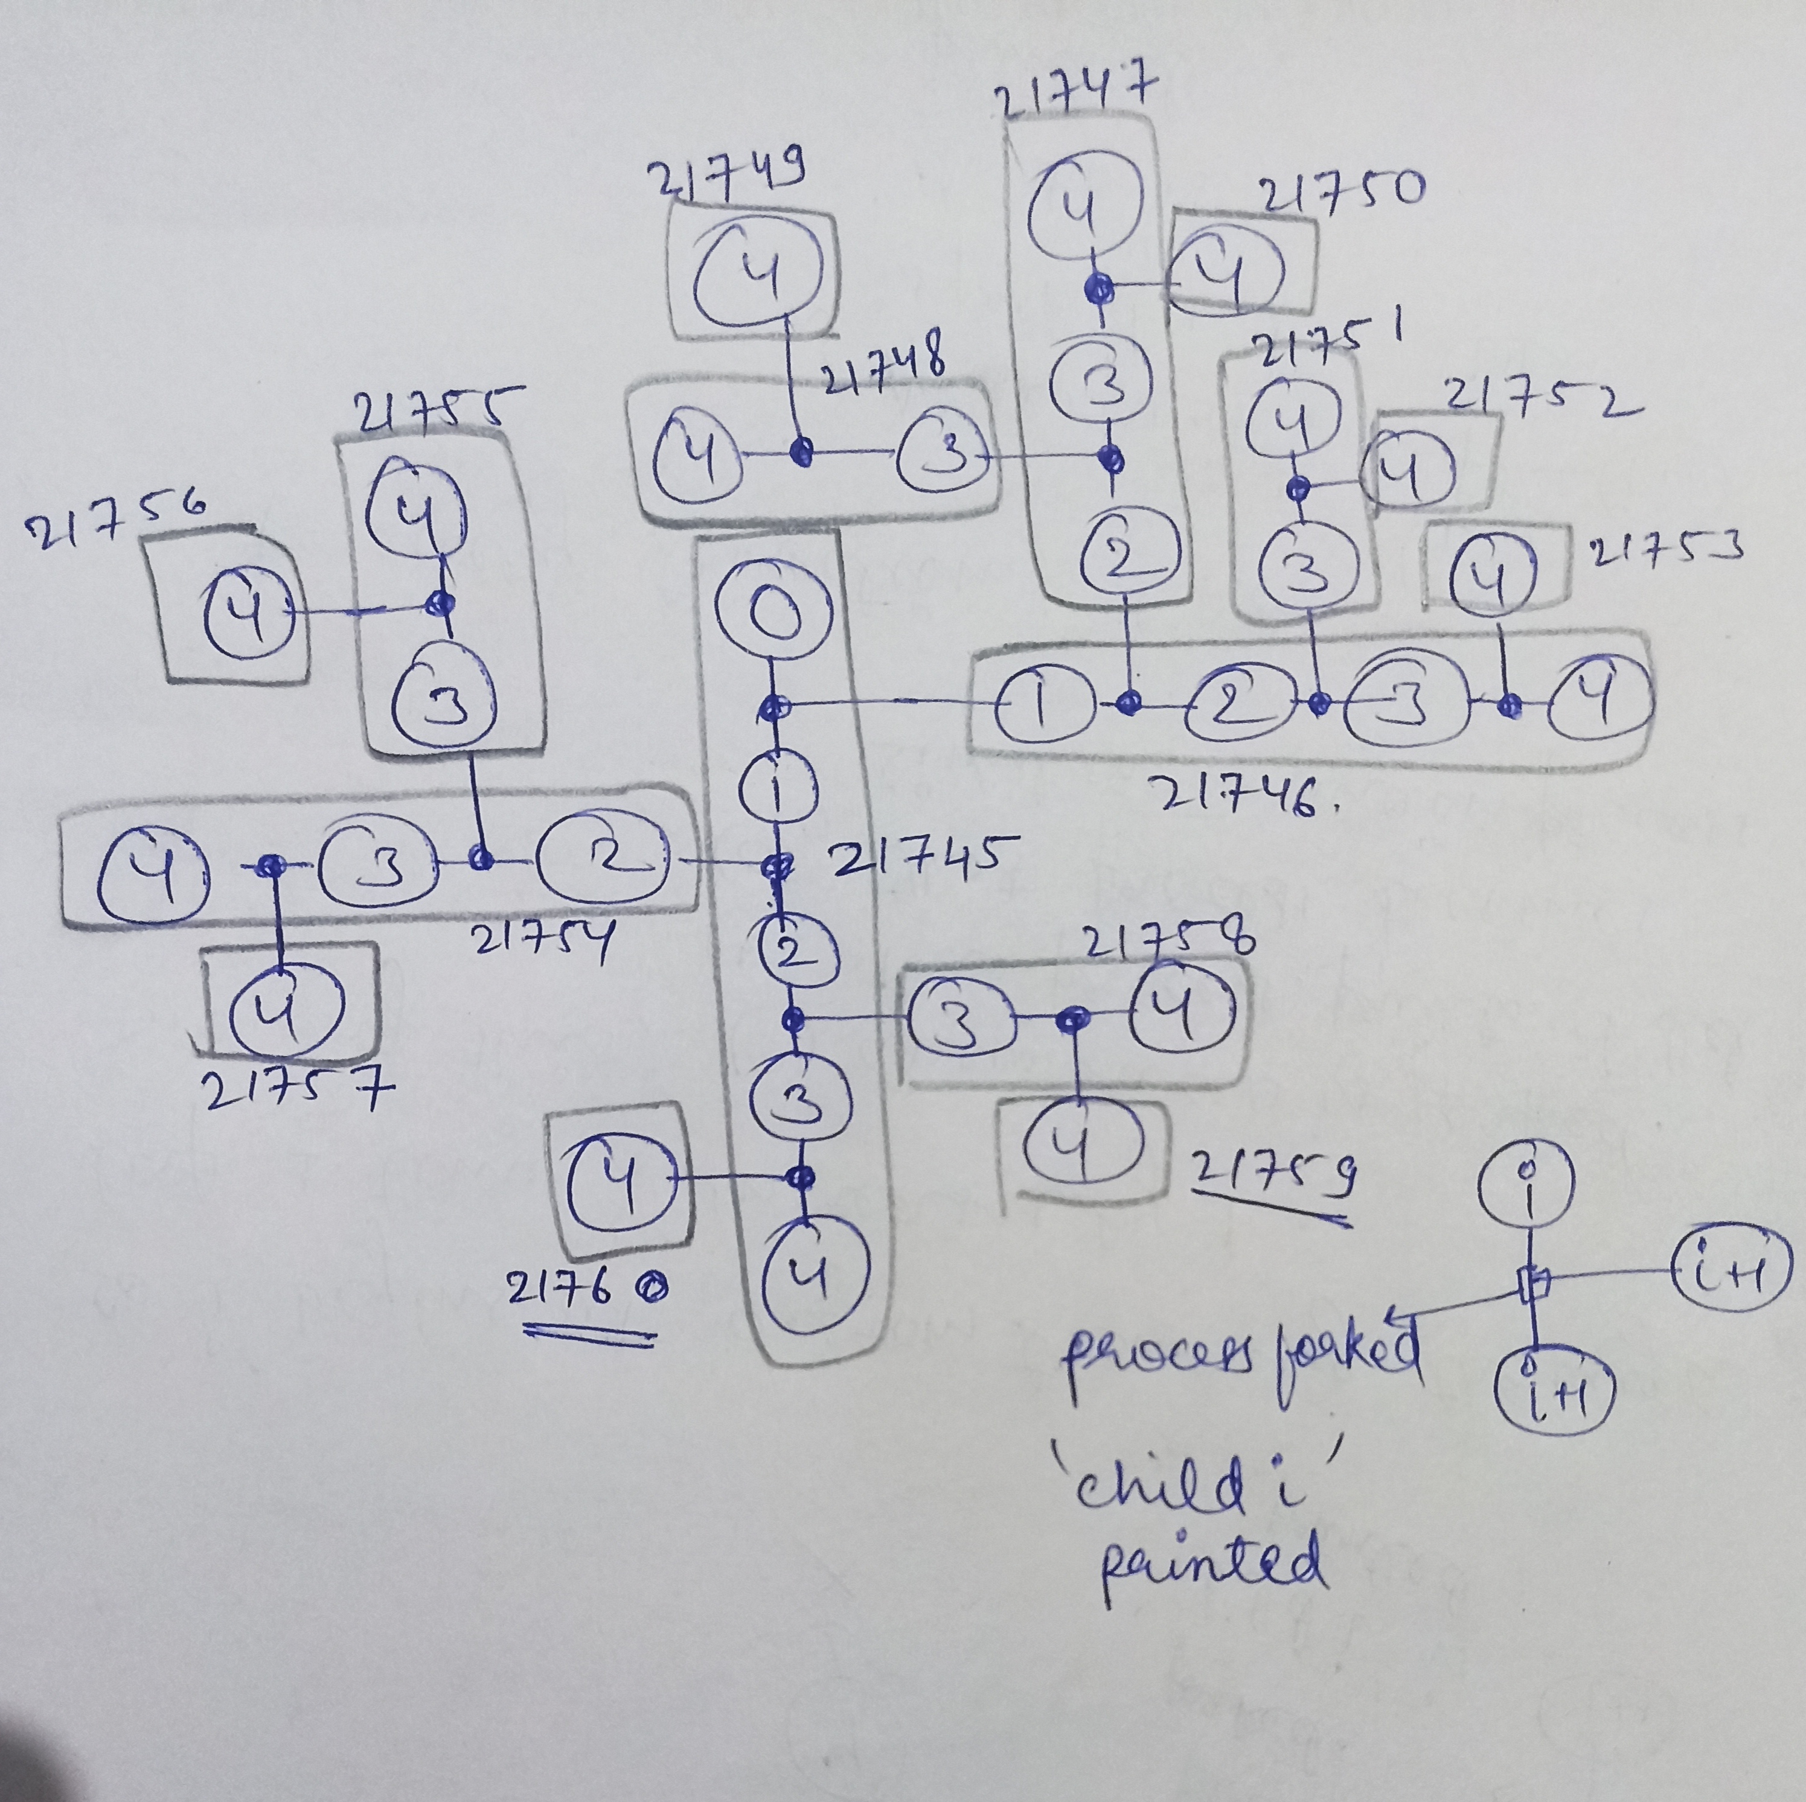
So by this way, there will be
1 child 0
2 child 1
4 child 2
8 child 3

One thing to note, the order of output is not fixed, as all the processes run simultaneously.

(b) tanmay@tanmay-VirtualBox:~/Assgn1$ ./fork4
The main parent pid: 21745
child 0
child 1
child 2
child 3
child pid 21749 ,parent pid 21748
child pid 21748 ,parent pid 21747
child 3
child pid 21750 ,parent pid 21747
child pid 21747 ,parent pid 21746
child 2
child 3
child pid 21752 ,parent pid 21751
child pid 21751 ,parent pid 21746
child 3
child pid 21753 ,parent pid 21746
child pid 21746 ,parent pid 21745
child 1
child 2
child 3
child pid 21756 ,parent pid 21755
child pid 21755 ,parent pid 21754
child 3
child pid 21757 ,parent pid 21754
child pid 21754 ,parent pid 21745
child 2
child 3
child pid 21759 ,parent pid 21758
child pid 21758 ,parent pid 21745
child 3
child pid 21760 ,parent pid 21745

EXPLANATION:
First the whole child process of any parent completes, and then the parent process resumes. By the chart we can cleary understand the outputs.

